Street Smart for ArcGIS Pro User Manual

Versie EN190322

Datum: 22 03 2019

© 2019 CycloMedia Technology B.V.

# Index

Index 2

1. Installation 3

2. How to use Street Smart for ArcGIS Pro 9

2.1 Exploring and viewing Cycloramas in ArcGIS Pro 9

2.1.1 How to show recording locations of Cycloramas 9

2.1.2 How to configure the Cyclorama viewers 9

2.1.3 How to open Cycloramas 10

2.2 How to show vector data in Cycloramas 11

2.3 Performing measurements 12

2.3.1 Point measurement 12

2.3.2 Standard measurement – line / surface measurement 14

# Installation

To install Street Smart for ArcGIS Pro, please perform the following steps:

1. Street Smart for ArcGIS Pro can be installed from a disk or network location:
   1. Copy the Add-In file to a (local) disk or network location.
   2. Start ArcGIS Pro.
   3. Select menu: *Project* ► *Add-In Manager* and select the *Options* tab.

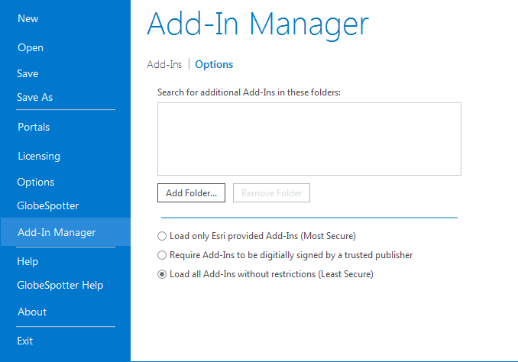

*Add-In Manager, Options tab*.

* 1. Click <*Add Folder...*>. Browse to the folder were the Add-In file is located and click <*OK*>.  
      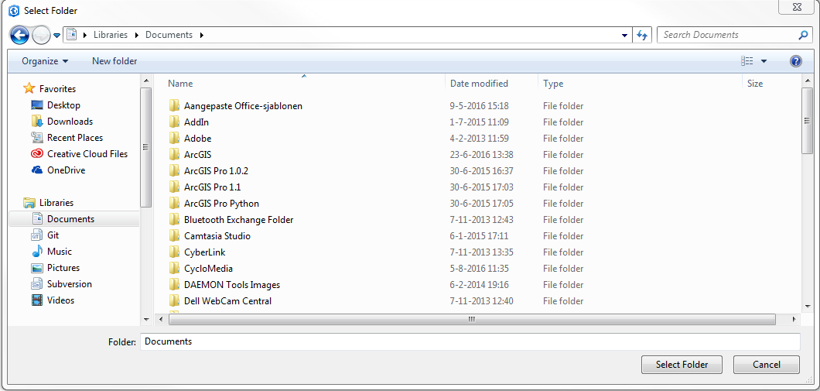

*Browse to the folder where the Add-In file is located.*

* 1. Close the Add-In Manager and restart ArcGIS Pro.
  2. Select menu: *Project* ► *Add-In Manager*.
  3. Check whether Street Smart for ArcGIS Pro is ‘*Authenticated’*. If the Add-In is ‘*Untrusted’*, close the Add-In Manager, close ArcGIS Pro and install the certificate ‘thawte-intermediate-ca.cer’ first (which is made available together with this user manual).

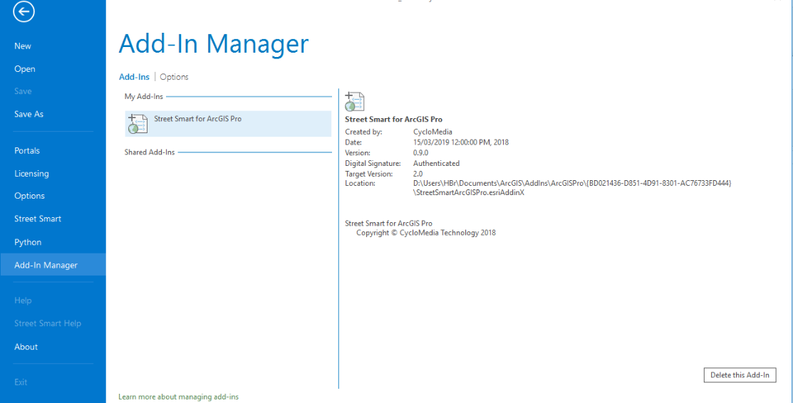

*Add-In Manager, Add-Ins tab, check if Street Smart for ArcGIS Pro is ‘Authenticated’ or ‘Untrusted’.*

* 1. To install the certificate, please perform the following steps:
     1. Double-click on ‘thawte-intermediate-ca.cer’ to install the certificate.  
          
         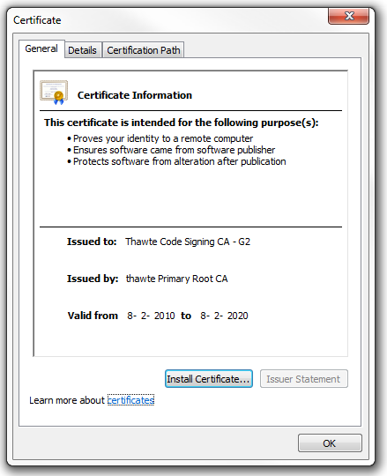

*Install the certificate.*

* + 1. Click on <*Install Certificate...*> to start the installation wizard for the certificate.   
         
       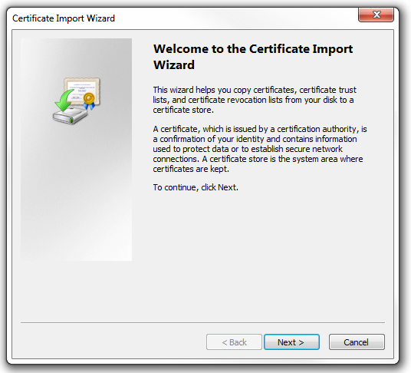

*Certificate Import Wizard.*

* + 1. Click: <*Next*>, <*Next*>, <*Finished*> to complete the installation of the certificate.  
         
        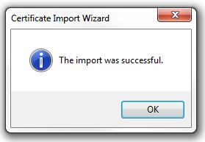

*The certificate is successfully imported.*

* 1. Start ArcGIS Pro.
  2. Select menu: *Project* ► *Add-In Manager*.
  3. Check if Street Smart for ArcGIS Pro is now ‘Authenticated’. You can then proceed to paragraph 2).   
       
     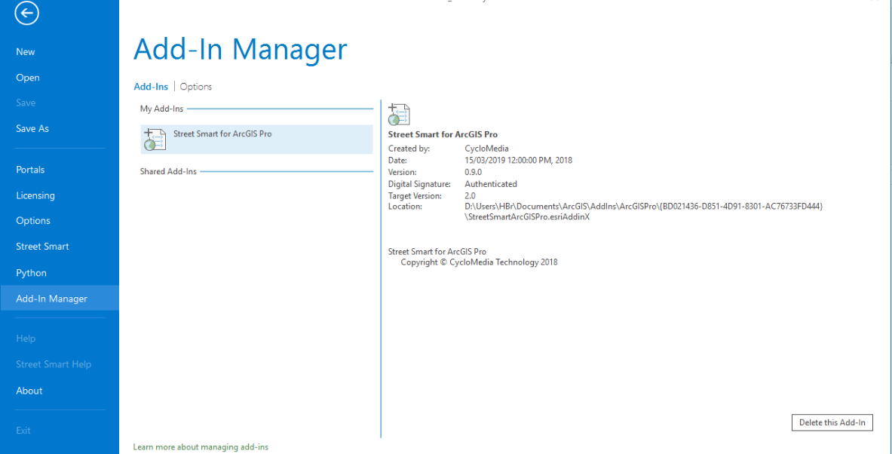

*Add-In Manager, Add-Ins tab, check that Street Smart for ArcGIS Pro is now ‘Authenticated’.*

1. If you start ArcGIS Pro for the first time after installing the Add-In, you will be shown the agreement form. Mark ‘*I have read and agree to the terms of use*’ as checked and click <*OK*>.  
     
   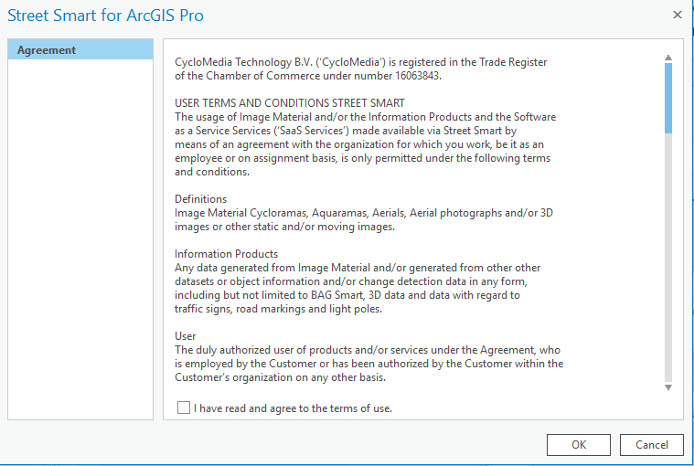

*Agreement form.*

1. Select the *Project* ► *Street Smart* menu. You will now open the window *Street Smart for ArcGIS Pro*.  
     
   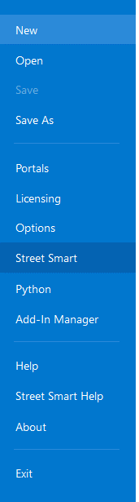

*Street Smart menu*

1. Select the tab *Configuration*.
2. If you use a proxy server, you can enable *Use a proxy server* and enter the data about your proxy server.  
    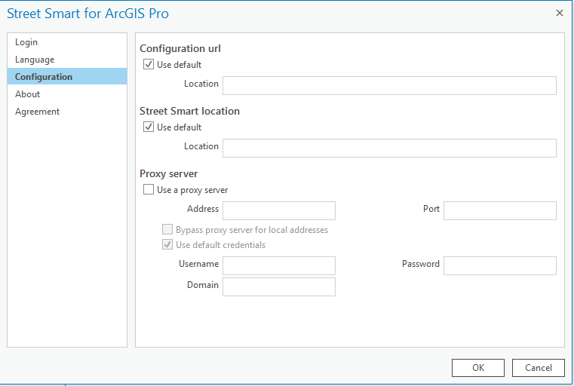

*Street Smart for ArcGIS Pro Add-In window, Configuration tab.*

1. If you are using a local installation, uncheck the base URL and the swf URL *Use default* option and enter the correct URLs at *Location* instead.
2. Select the *Login* tab.
3. Enter your username and password and press: <*Apply*>. If you see the message ‘*Login Successfully*’, you are ready to use Street Smart for ArcGIS Pro.   
     
   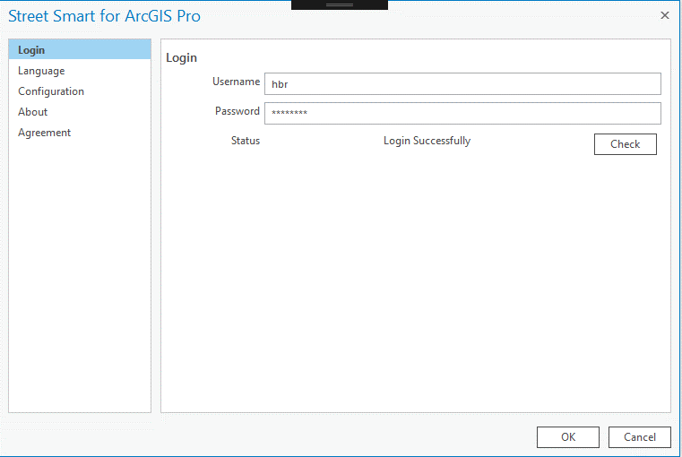

*Street Smart for ArcGIS Pro Add-In window, Login tab.*

# How to use Street Smart for ArcGIS Pro

## Exploring and viewing Cycloramas in ArcGIS Pro

### How to show recording locations of Cycloramas

1. Select *Recent Recording Layer* in the Street Smart tab.   
   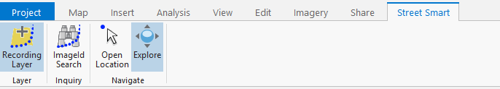

*The selected Recent Recording Layer icon.*

1. In the *Table Of Contents* of ArcGIS Pro a new layer will appear as shown in the figure below. Zoom in on the map to a zoom level of at least 1:2000 to see the recording locations on the map (provided there are recordings in the area).  
    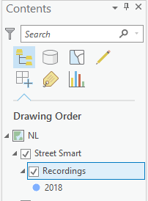

*The layer with recordings in the Table Of Contents.*

### How to configure the Cyclorama viewers

1. Select in the *Table Of Contents* the map, right click on the mouse button ► *Properties* menu. You will now open the window *Map Properties*.
2. Select the *Street Smart* tab.  
     
   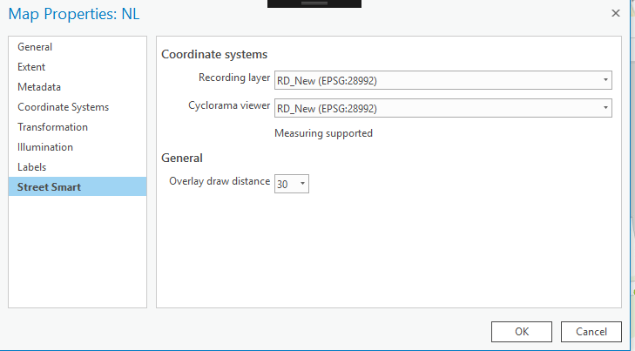

*Cyclorama viewing settings in the Street Smart tab.*

1. Select the coordinate system which the viewer(s) should use.
2. Select the coordinate system which the Recording layer should use.
3. Select overlay draw distance of overlays (in meters)
4. Press <*OK*> for the changes to take effect.

### How to open Cycloramas

1. Select the *Open Location Tool* in the Street Smart toolbar.  
   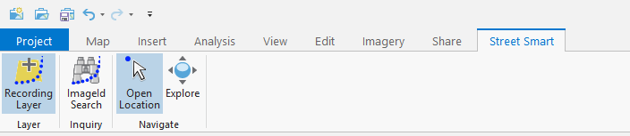

*The selected Open Location Tool icon*.

1. Click on a dot for the corresponding Cyclorama to open in a Cyclorama viewer.
2. Click on another dot with shift-pressed and a second Cyclorama will open.
3. If the shift key isn’t pressed, the first Cyclorama will be replaced by the second Cyclorama.   
     
   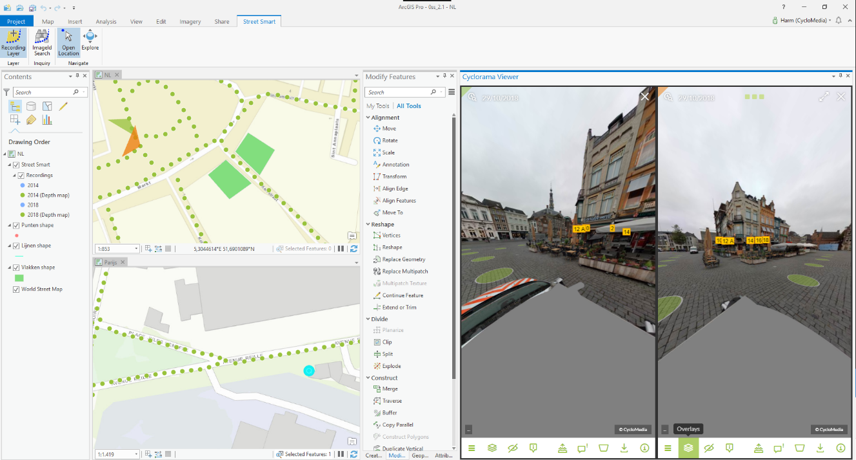

*Street Smart for ArcGIS Pro with two Cyclorama viewers opened.(shift-click)*

## How to show vector data in Cycloramas

1. Add one of the various types of vector data to the Table Of Contents, such as:
   * Shapefiles
   * ArcSDE
   * Personal MDB
   * File GDB
2. Open a Cyclorama. Note that the vector data will now be shown in the Cycloramas.   
     
   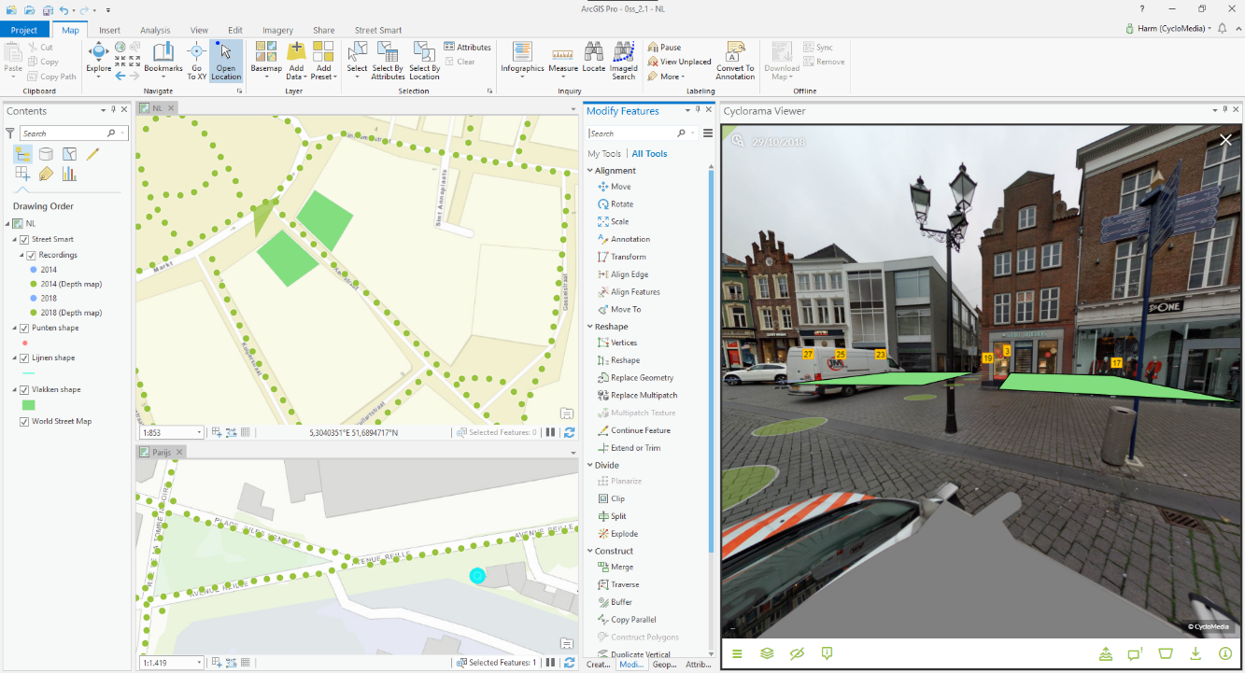

*Showing vector data as overlay in the Cyclorama viewers.*

1. Optionally, set the distance at which vector layer data is displayed in the *Map Properties* ► *Street Smart* menu. The default distance is 30 meters, which means only vector data located within 30 meters of the recording location will be displayed.

## Performing measurements

Measurements are stored in vector data layers. Point, line or surface measurements each are stored in separate point, line or polygon vector data layers. The following sections explain in detail how to perform the various types of measurements. To illustrate the principle of measuring, this manual will guide you through the process of performing standard measurements first, before explaining measuring with Smart Click (which is turned on by default).

* + *Point measurement*
  + *Line / surface measurement*

### Point measurement

1. Add a point vector data layer to the map to store the measurement(s).
2. Open a Cyclorama in which the object to measure is clearly visible.
3. Select the tab: *Edit* ► *Create* to start editing mode in ArcGIS Pro.  
     
   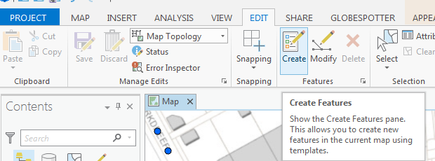

*Start editing mode in the newly added vector layer.*

1. Select the point layer in the *Create Features* window to start a point measurement.  
   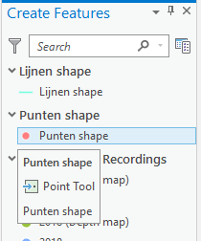

*The Create Features window with several vector layers.*

1. You can select the measure method in the Cyclorama (Measure Smart / Smart Click / Forward intersection)



*The Measure mode bar*

1. Select the point you want to measure in the Cyclorama.

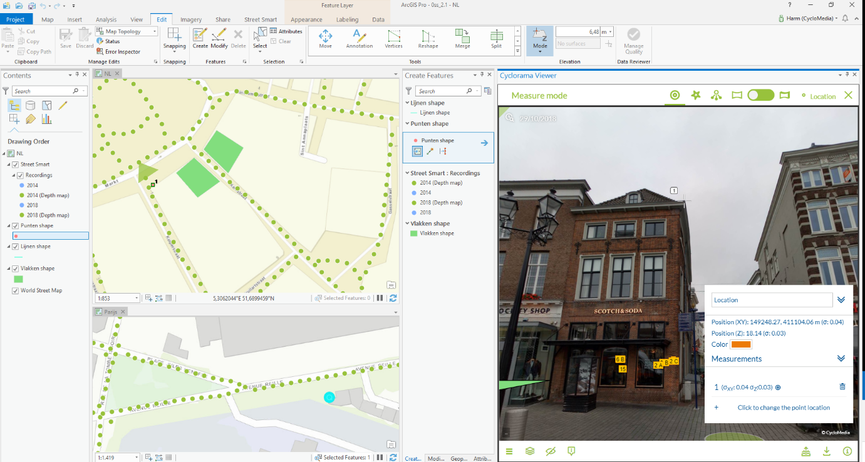

*Performing a point measurement.*

1. It is possible for change the measurement now. If the measurement is correct, you can proceed to point 8.
2. If you are finished with the measurement, click the <*Location*> button in the top of the *Measurement mode* bar.
3. If you are finished with your measurements, save the edits to the vector layer in the *Edit* tab in ArcGIS Pro, as shown in the figure below.   
   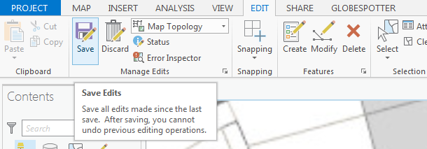

*Save edits in ArcGIS Pro.*

### Line / surface measurement

1. Add a line or a polygon vector data layer to the map to store the measurement(s).
2. Open a Cyclorama in which the object to measure is clearly visible.
3. Select the tab: *Edit* ► *Create* to start editing mode in ArcGIS Pro.
4. Select the line or polygon layer in the *Create Features* window to start a line or a surface measurement.
5. You can select the measure method in the Cyclorama (Measure Smart / Smart Click / Forward intersection)
6. Select the point you want to measure in the Cyclorama.
7. Then select the second and subsequent points you want to measure, until you have selected all the points you want to measure.  
   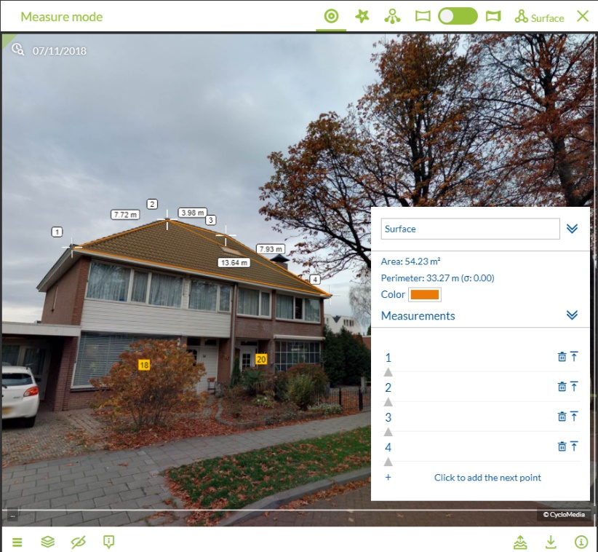

*Select all the points in the first Cyclorama step by step.*

1. It is now possible to edit points if this is desirable.
2. If you are finished with the measurement, click the <*Close*> button in the bottom of the *Selected Measurement Details* window.
3. Click on the *Finish Sketch* button on the toolbar in the map or the *<Surface>* button in the measure bar in the cyclorama. With one of these buttons, you can close the measurement.  
     
   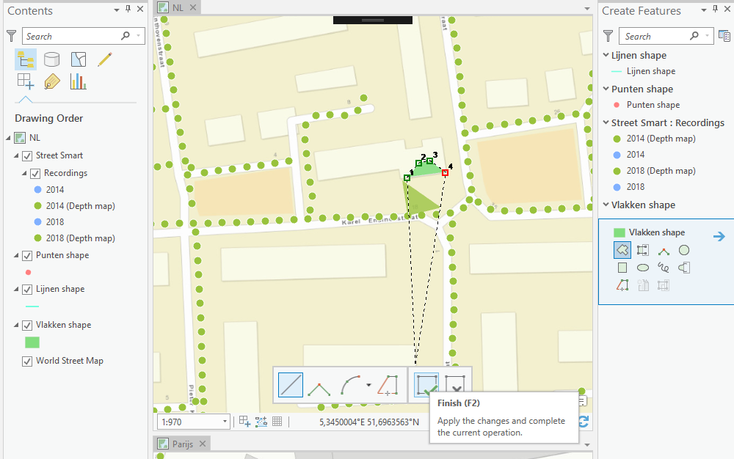

*Use Finish Sketch on the toolbar of the bottom of the screen to close the measurement.*

1. If you are finished with your measurements, save the edits to the vector layer in the *Edit* tab in ArcGIS Pro  
     
   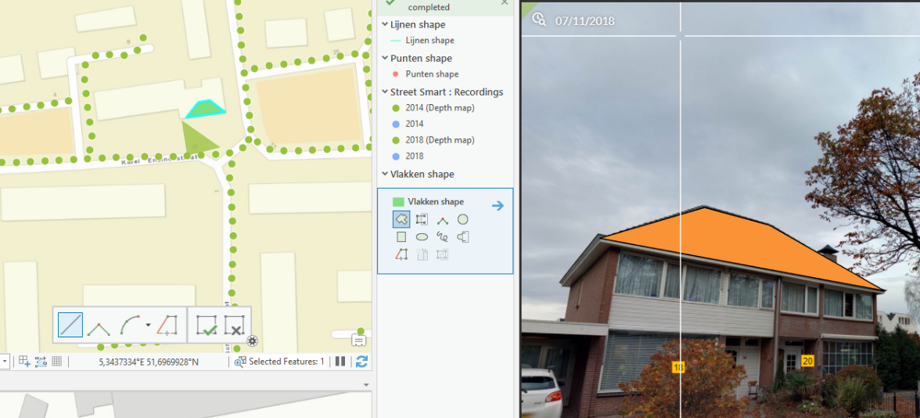

*After selecting the points in the second Cyclorama, the measurement is complete.*

### How to import a measurement in a Cyclorama

1. Select the *Move* or *Verticles* option in the *Edit* tab.  
     
   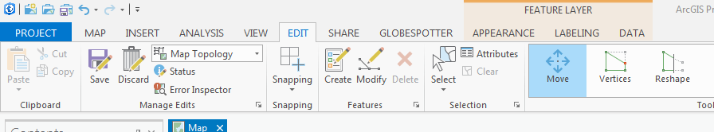

*The Edit tab.*

1. Select a feature on the map to select the overlay of the measurement in the Cyclorama.  
     
   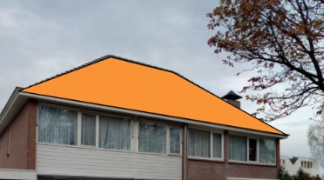

*Selected overlay in the Cyclorama.*

1. If you want to edit the (selected) feature, select the *Vertices* option in the *Edit* tab.  
     
   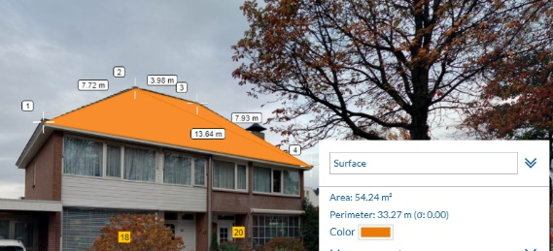

*Measurement shown in the Cyclorama (After use the Verticles option).*

1. It is now possible to edit the measurement in the Cyclorama or on the map.

If you want to edit a measurement point in the Cyclorama, select that point in the map.

## Cyclorama search functionality

1. To start the cyclorama search functionality, click on the *ImageId search* button in the *Street Smart* tab.

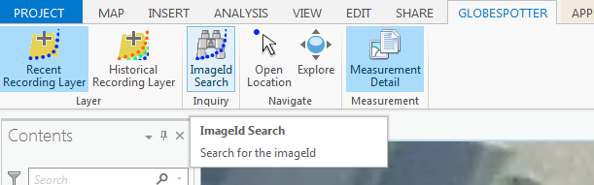

*ImageId search button*

1. You will now see the ImageId search window.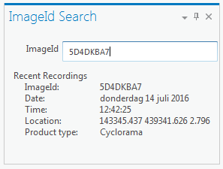

*Find Cyclorama window*

1. Enter an imageId and you will get the results
2. Double-click a result and you go to the cyclorama.